LAB # 01
INTRODUCTION TO ECLIPSE IDE
OBJECT:
Introduction to Eclipse IDE, creating projects, its classes and mapping UML class diagram in to java code.
LAB TASK:
Write the java code with the help of the given class diagram of Hospital Management System.
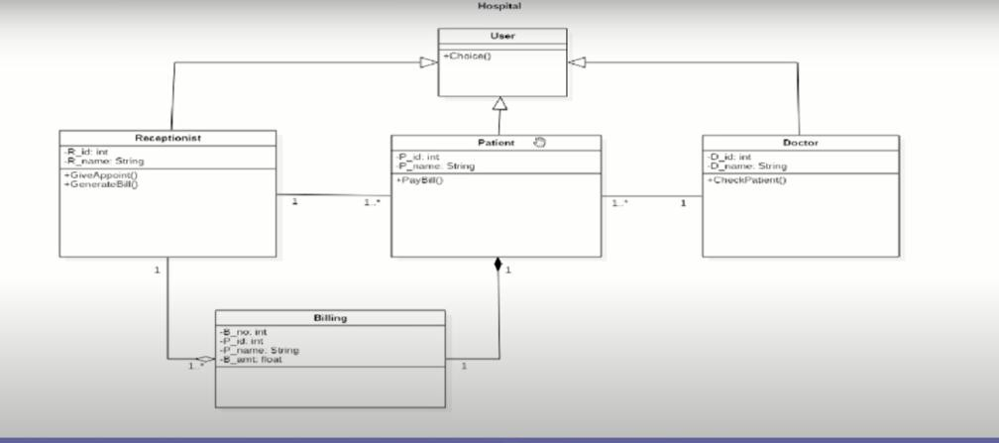

CODE:
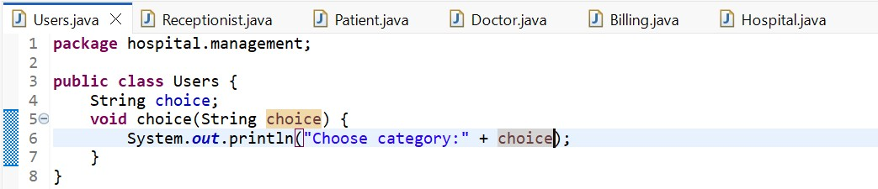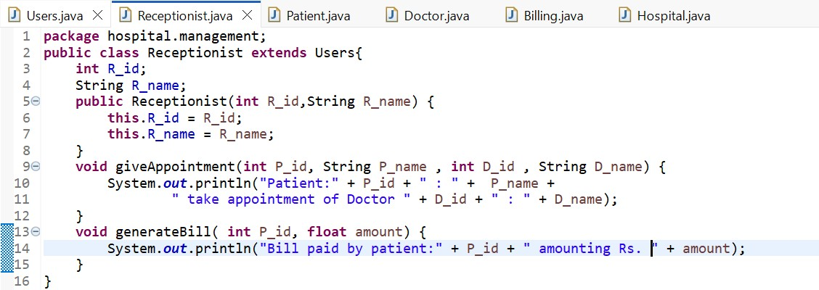

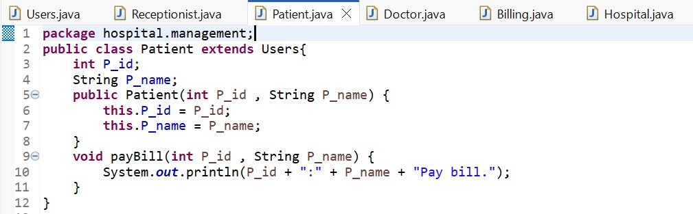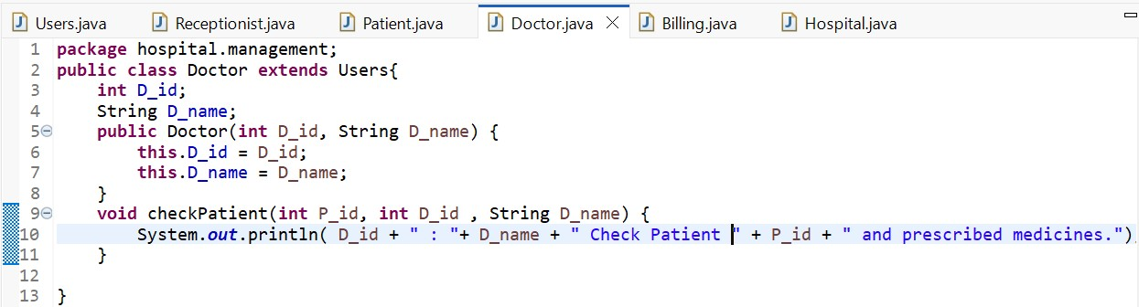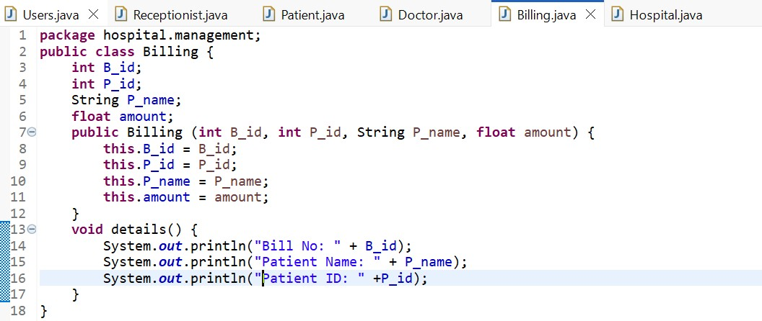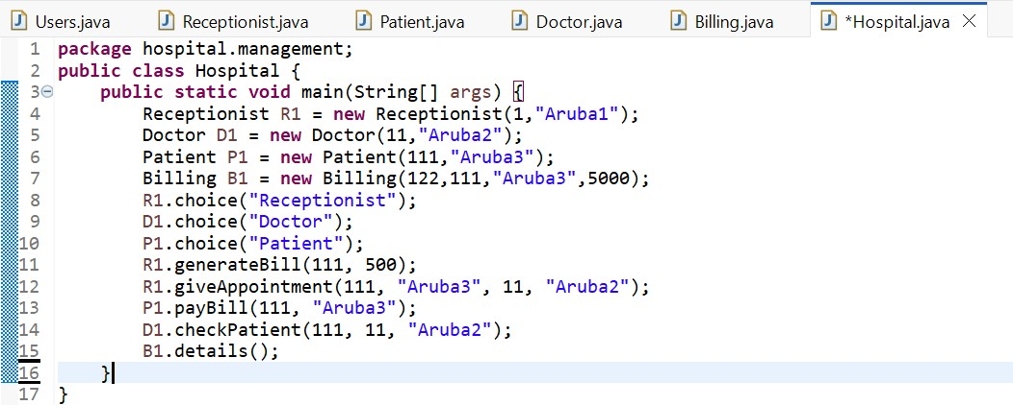
OUTPUT:
